Clicking on add to cart multiple times

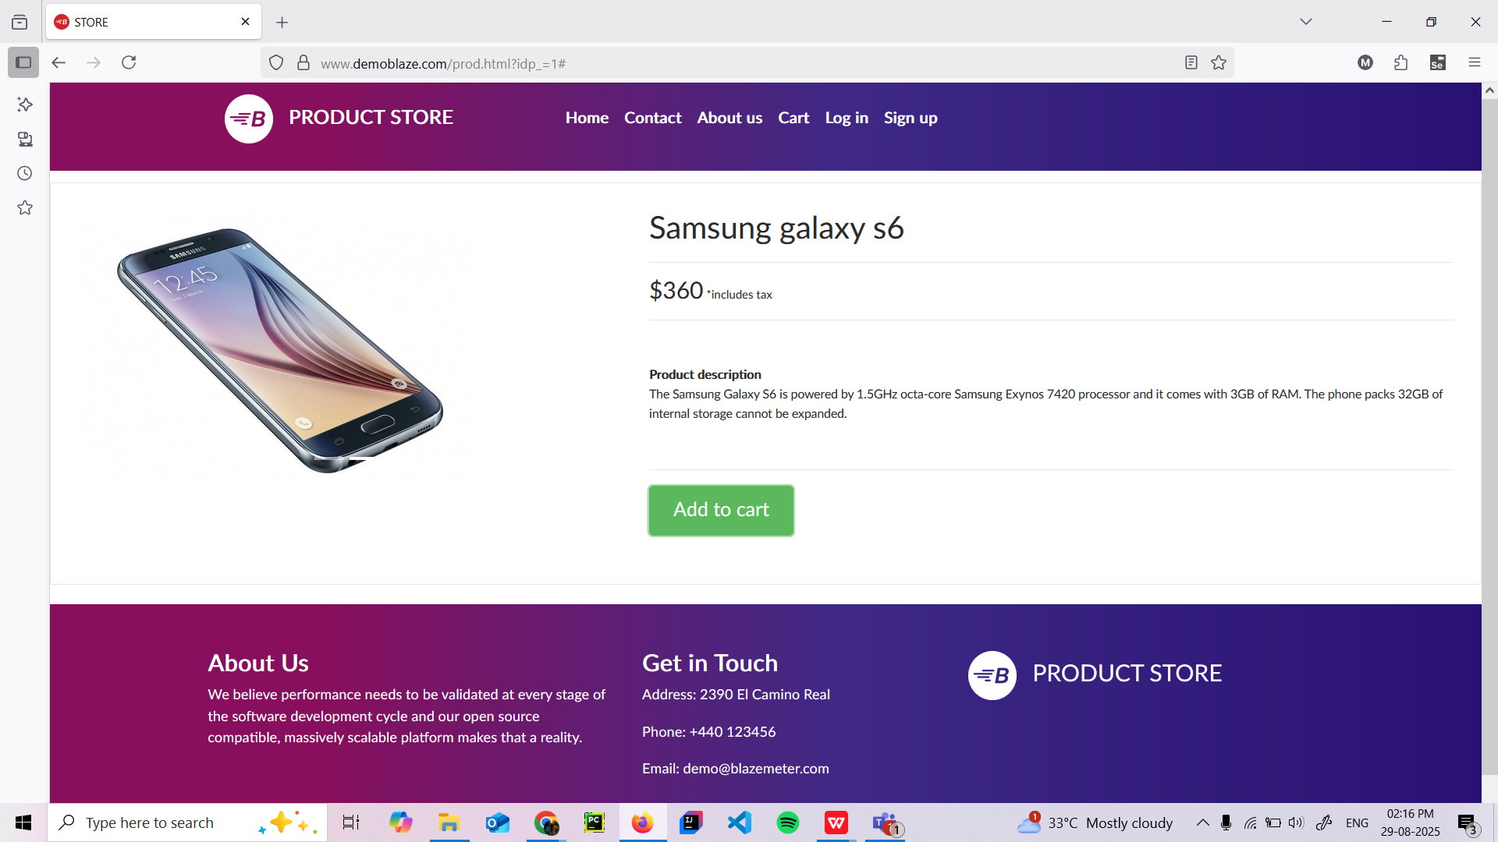

Alert is shown : “product added” again and again repeatedly

